**BASIC FORMATTING TAGS**

**AIM:**

To use basic formatting html tags and to study their description .

**PROCEDURE:**

The basic formatting tags and their explanation and usage in html, are as follows,

|  |  |  |
| --- | --- | --- |
| **S.NO** | **HTML TAGS** | **DESCRIPTION** |
| 1 | <html> | The html tag in HTML is used to define the root of HTML and XHTML documents. |
| 2 | <a herf=” “> …</a> | create a hyperlink on the webpage. |
| **3** | **<button type = “button”>** | define the clickable button |
| **4** | **<code>** | define the piece of computer code. |
| **5** | **<div>** | make divisions of content in the web page |
| **6** | **<footer>** | define a footer of HTML document |
| **7** | **<head>** | define the head portion of the document which contains information related to the document. |
| **8** | **<img src=”” alt=”” width=”” height=””>** | add the image in HTML |
| **9** | **<label>** | provide a usability improvement for mouse users. |
| **10** | **<meta attribute-name=”value”>** | it provides important information about a document. |
| **11** | **<em>** | used to indicate the structural meaning of a block of text. |
| **12** | **<script>** | The script tag in HTML is used to define the client-side script. |
| **13** | **<section>** | defines the section of documents such as chapters, headers, footers, or any other sections. |
| **14** | **<span>** | The HTML span element is a generic inline container for inline elements and content. |
| **15** | **<table>… </table>** | HTML Table is an arrangement of data in rows and columns, or possibly in a more complex structure. |
| **16** | **<video src=”” controls> </video>** | HTML5 Video, along with knowing the different ways to add the videos to the HTML page. |
| **17** | **<link>** | Defines the relationship between a document and an external resource |
| **18** | **<meter>** | Defines a scalar measurement within a known range (a gauge) |
| **19** | **<p>** | Defines a paragraph |
| **20** | **<svg>** | Defines a container for SVG graphics |
| **21** | **<li>** | Defines a list item |
| **22** | **<ol>** | Defines an ordered list |
| **23** | **<ul>** | Defines and unordered list |
| **24** | **<input>** | Defines an input control |
| **25** | **<var>** | Defines a variable |

**SOURCE CODE :**

<!DOCTYPE html>

<html lang="en">

<head>

<meta charset="UTF-8">

<meta name="viewport" content="width=device-width, initial-scale=1.0">

<meta http-equiv="X-UA-Compatible" content="ie=edge">

<title>Basic HTML5 Page</title>

<style>

body {

font-family: Arial, sans-serif;

}

</style>

</head>

<body>

<header>

<h1>Welcome to the Basic HTML5 Page</h1>

</header>

<nav>

<ul>

<li><a href="#section1">Section 1</a></li>

<li><a href="#section2">Section 2</a></li>

</ul>

</nav>

<section id="section1">

<h2>Section 1: Introduction</h2>

<p>This is the first section of the page.</p>

<article>

<h3>Article 1</h3>

<p>This is an article within Section 1.</p>

</article>

<aside>

<p>This is an aside, usually related but not critical to the main content.</p>

</aside>

</section>

<section id="section2">

<h2>Section 2: Main Content</h2>

<p>This is the second section of the page.</p>

<figure>

<img src="https://picsum.photos/200" alt="Sample Image" usemap="#image-map" />

<map name="image-map">

<area shape="rect" coords="0,0,200,200" alt="Top Left" href="https://www.google.com/" />

<area shape="circle" coords="400,100,50" alt="Circle Area" href="https://www.github.com" />

<area shape="poly" coords="250,150,300,300,200,300" alt="Polygon Area" href="https://boot.dev" />

</map>

<figcaption>Placeholder image</figcaption>

</figure>

</section>

<footer>

<p>&copy; 2025 Sivasubramani. All rights reserved.</p>

</footer>

<form action="#" method="post">

<label for="name">Name:</label>

<input type="text" id="name" name="name">

<input type="submit" value="Submit">

</form>

<address>

Contact us at <a href="mailto:someone@example.com">someone@example.com</a>

</address>

</body>

</html>

**OUTPUT 1 :**

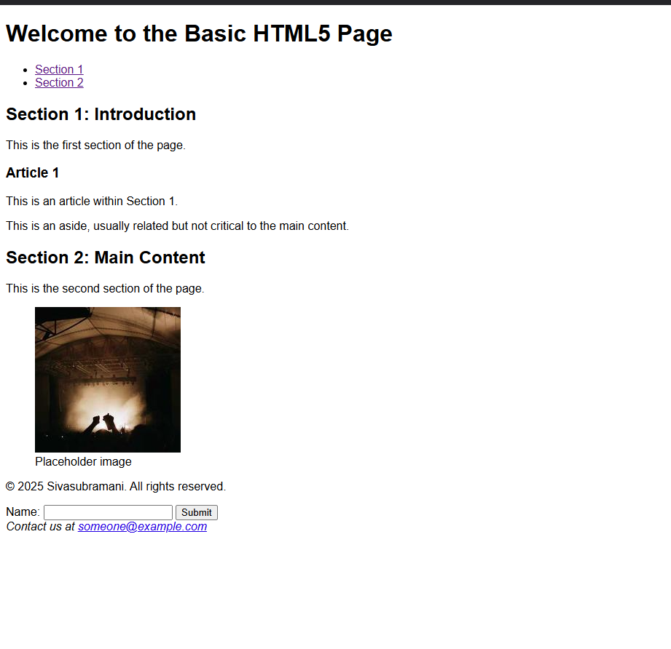

**RESULT :**

**The basic formatting tags have been successfully implemented, the purposes and studied and the functionalities are observed.**